**Exercise 1: Control Structures**

**TABLE :**

CODE**:**

CREATE TABLE Customers (

CustomerID NUMBER PRIMARY KEY,

Name VARCHAR2(100),

Age NUMBER,

Balance NUMBER(10,2),

IsVIP VARCHAR2(5) DEFAULT 'FALSE'

);

CREATE TABLE Loans (

LoanID NUMBER PRIMARY KEY,

CustomerID NUMBER REFERENCES Customers(CustomerID),

InterestRate NUMBER(5,2),

DueDate DATE

);

INSERT INTO Customers VALUES (1, 'Alice', 65, 15000, 'FALSE');

INSERT INTO Customers VALUES (2, 'Bob', 45, 8000, 'FALSE');

INSERT INTO Customers VALUES (3, 'Charlie', 70, 11000, 'FALSE');

INSERT INTO Customers VALUES (4, 'Diana', 58, 9500, 'FALSE');

INSERT INTO Loans VALUES (101, 1, 7.5, SYSDATE + 15);

INSERT INTO Loans VALUES (102, 2, 6.8, SYSDATE + 40);

INSERT INTO Loans VALUES (103, 3, 8.2, SYSDATE + 10);

INSERT INTO Loans VALUES (104, 4, 7.0, SYSDATE + 5);

COMMIT;

**TABLES :**

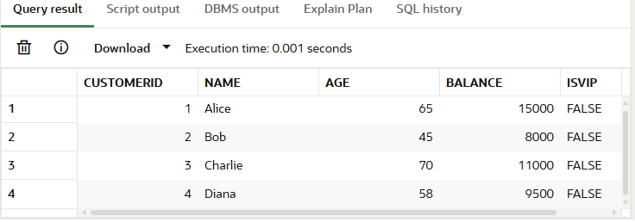

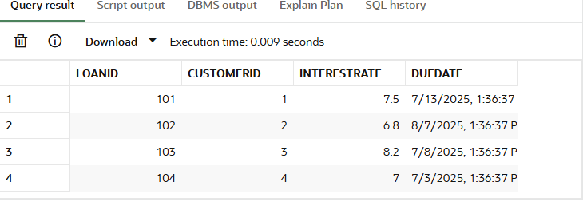

**Scenario 1: The bank wants to apply a discount to loan interest rates for customers above 60 years old.**

**CODE:**

BEGIN

FOR cust_rec IN (SELECT CustomerID FROM Customers WHERE Age > 60) LOOP

UPDATE Loans

SET InterestRate = InterestRate - 1

WHERE CustomerID = cust_rec.CustomerID;

END LOOP;

COMMIT;

END;

**OUTPUT :**

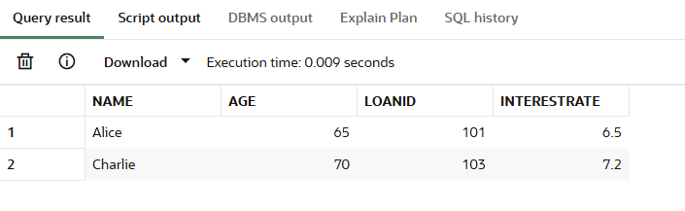

**Scenario 2 : Promote Customers with Balance > $10,000**

**CODE :**

BEGIN

FOR cust_rec IN (SELECT CustomerID FROM Customers WHERE Balance > 10000) LOOP

UPDATE Customers

SET IsVIP = 'TRUE'

WHERE CustomerID = cust_rec.CustomerID;

END LOOP;

COMMIT;

END;

**OUTPUT :**

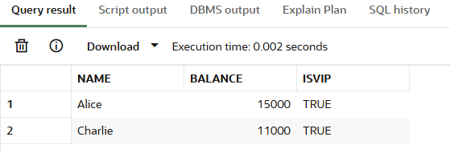

**Scenario 3: Send Reminders for Loans Due in 30 Days**

**CODE :**

BEGIN

FOR loan_rec IN (

SELECT L.LoanID, L.CustomerID, L.DueDate, C.Name

FROM Loans L

JOIN Customers C ON L.CustomerID = C.CustomerID

WHERE L.DueDate <= SYSDATE + 30

) LOOP

DBMS_OUTPUT.PUT_LINE('Reminder: Loan ' || loan_rec.LoanID ||

' for customer ' || loan_rec.Name ||

' is due on ' || TO_CHAR(loan_rec.DueDate, 'DD-MON-YYYY'));

END LOOP;

END;

**OUTPUT :**

